About New Prospects

We are New Prospects, and we have been supporting people with a learning disability for more than 30 years. We support people to live the lives they choose whether they need support 24 hours a day or just a little each week. We've learned a lot over the years from people we support, their families and our staff - we'll keep on learning and changing to make sure we stay focused on giving people what they want. We are a Co-operative and Community Benefit Society, so we are not here for profit, we only exist to support people to live their good life. We are small, local and well connected. Being small doesn't mean we don't think BIG!

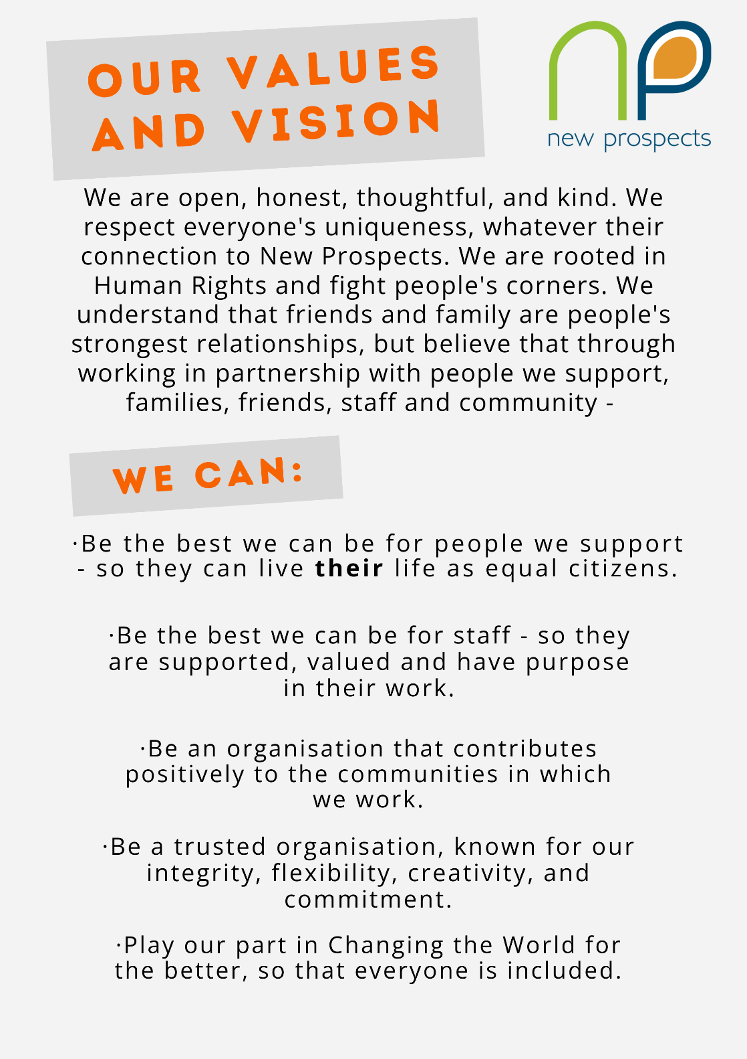

Role Details
Job Title: | Support Worker (BSL)
Salary: | £13.45 per hour. Sleep-In support paid at £83.50.
Reports to: | Support Manager
About the person, (or people) you will be supporting: | J is a deaf lady in her 30s who has lived in her own flat for 14 years and communicates by British Sign Language. She’s looking for support staff to assist with cooking, shopping and housework. J has a busy week and is active in the deaf community, as well as her local community. Staff support her to deaf clubs, art classes and table tennis which she loves attending. She is well known in local cafes and enjoys going to the pub with staff, especially to watch the football. J is an active part of a large family who she visits regularly.
Your role as a Support Worker: | One of our team said, “the best thing about our work is you have the power to make someone else’s day” that is so true. If we see the people we support as our equal, treat each other with respect, and see possibilities, our support workers can have a huge impact on people’s lives – supporting people to be independent, to be in control of their own lives and make their mark on the world. We support people with whatever it takes to help them live their life.
Location: | Monkseaton
Working Hours: | Up to 39 hours per week (including evenings, weekends, and bank holidays) Sleep-In support paid separately.

Responsibilities and Duties of the Job
Day to day support: | - Follow individual support plans, ensuring that the support provided meets the personal goals and aspirations of those you support.  - Provide practical support, including personal care, support with cooking, cleaning and all the things that make up life! Ensuring that the dignity and preferences of the person supported are respected.  - Maintain accurate records, ensuring proper documentation of support is provided.  - Support people to manage their medication and support them in making informed decisions about their health.  - Follow safeguarding procedures to maintain the safety and well-being of the people supported.  - Focus on people’s strengths and abilities celebrating what people can do - supporting them with things they find difficult.  - Live our values with people we support, their families and colleagues, being open, honest, thoughtful and kind.  - We support people to live life, so any other reasonable duties to support people in life may be expected.

Supporting Everyday Citizenship: | - Support people to get stuck into life, helping them build positive relationships with their neighbours, peers, and their neighbourhood.  - Encourage the development of friendships, maintain and build family relationships and support people to find and experience love.  - Support people to find, or follow, their purpose in life. Looking for opportunities for people to make their mark on the world through work or volunteering.  - Support people to maintain and develop financial independence, supporting them to budget and control their money.  - Support people to be as in control of their life as possible, support people to be free, and live the life they choose.  - Support people to live in their home, making sure they experience living life – not living in a service.  - Make sure people are experiencing support that does things with them not to them.  - Respect (and explore) people’s cultural, spiritual, and personal identity.
Teamwork: | - Communicate with your teammates, sharing ideas, concerns and day to day information.  - Attend team meetings and contribute to the development of shared solutions, reviews of support plans etc.  - Speak up to your manager if you have any concerns, big or small.  - We do not use agency staff so you may occasionally be required to support other people supported by New Prospects.
Personal and Professional Development: | - Take part in training and development opportunities to enhance your skills and knowledge relevant to supporting people with a learning disability and/or autism.  - Attend staff meetings, supervision, and performance reviews as part of your professional growth and contribution to the team.  - Take advantage of opportunities to share your ideas about the organisation through surveys, planning days and conferences.

Person Specification
Your Qualifications | Essential | Desirable
4 GCSEs or equivalent, including English Language at Grade C or above |  | x
Competent in British Sign Language | x
British Sign Language Level 1 or above |  | x
Full, clean, driving license. |  | x

Your Previous Experience | Essential | Desirable
Previous experience of working with people with a learning disability and/or autism. |  | x
Experience and understanding of the difficulties people with a learning disability and/or autism might face. |  | x

Your Skills | Essential | Desirable
Written Skills
Ability to keep accurate records | x
Good reading skills to follow support plans | x
Organisational Skills
Ability to prioritise workload | x
Taking responsibility for things that need to be done, not leaving things to others. | x
Good time management skills | x
Ability to organise yourself so you can help people we support make the most of their days. | x
Communication Skills
The ability to communicate verbally in a professional but friendly manner. | x
The ability to explain letters and information in an easy-to-understand way for people we support. | x
To be able to communicate clearly and effectively with people we support, families, staff and professionals | x
Problem-solving Skills
To see solutions not just problems, be a creative thinker. | x
The ability to remain calm under pressure, remaining kind and respectful when the going gets tough. | x
IT and Computer Skills
Good basic computer skills | x
Ability to use mobile phone/tablet to access apps | x

Your Personal Attributes | Essential | Desirable
Disposition/Personal Attributes
Thoughtful | x
Calm under pressure | x
Committed to equality and inclusion | x
Have a sense of humour | x
Flexible approach to hours of work | x

Area | Matching Your Personal Attributes to Our Values
Openness and Honesty | - Speak up when things go wrong  - Hold your hands up if you drop a clanger  - Don’t sit with problems, share them
Thoughtfulness and Curiosity | - Be kind, see everyone as your equal, treat everyone as your equal.  - Ask why? Explore possibilities.
Wanting the best for people we support and staff | - Understand that our purpose is to support people well this includes staff.  - Have high expectations of what is possible for people we support and their teams.
Focus on Rights and Citizenship | - Learn and live the Keys to Citizenship.  - Understand and safeguard people’s rights.  - Highlight when they way we work, impacts on people’s rights and threatens their citizenship.
The Value of Community | - Understand that real life happens in the real world.  - Seek ways for people to get involved and contribute to their community.
Changing the World | - Understand that inclusion for people we support makes the world a better place for everyone.  - Understand that rights protected for people we support enhances rights for all.

